



Essay / Assignment Title: Descriptive and Inferential Statistics for Strategic Business Decision-Making

Programme title:

Name:

Year:

CONTENTS

CONTENTS 2
LIST OF FIGURES 5
INTRODUCTION 8
1. 1 Context and Relevance 8
1. 2 Objectives 8
1. 3 Report Structure 8
CHAPTER ONE: DATA OVERVIEW 9
2. 1 Dataset Description 9
2. 2 Initial Observations 9
CHAPTER TWO: DATA CLEANING AND PREPARATION 10
3.1 Identifying and Handling Noisy Data 10
3.2 Outlier Detection and Treatment 11
3.3 Missing Data Treatment 13
CHAPTER THREE: DESCRIPTIVE STATISTICAL ANALYSIS 16
4.1 Measures of Central Tendency 16
4.2 Measures of Variability 16
4.3 Data Distribution Analysis 17
CHAPTER FOUR: DATA NORMALIZATION AND VISUALIZATION 19
5.1 Data Normalization Techniques 19
• Min-Max Scaling 19
• Z-Score Standardization 19
5.2 Visualization Techniques 20
CHAPTER FIVE: INFERENTIAL STATISTICAL ANALYSIS 29
6.1 Introduction to Inferential Statistics 29
6. 2 Hypothesis Testing 29
6.2.1. T-Test 29
6.2.2. ANOVA (Analysis of Variance): 30
6. 3 Confidence Intervals 30
6. 4 Interpretation of Results 31
CHAPTER SIX: DISCUSSION OF FINDINGS 32
7.1 Key Insights from Descriptive Statistics 32
7. 2 Impact of Inferential Statistics 32
CONCLUDING REMARKS 34
8. 1 Summary of Key Concepts 34
8. 2 Final Thoughts on Data-Driven Decision-Making 34
BIBLIOGRAPHY 36

LIST OF FIGURES

Figure 1: RStudio Environment with Air Quality Dataset and Initial Data Exploration 9
Figure 2: RStudio Environment with Air Quality Dataset and Initial Data Exploration 10
Figure 3: RStudio Console Output: Calculating Z-scores for Ozone and Identifying Outliers in Air Quality Dataset 11
Figure 4: RStudio Console Output: Removing outliers from the airquality dataset and creating a cleaned dataset 11
Figure 5: RStudio Console Output: Removing outliers from the airquality dataset and creating a cleaned dataset 12
Figure 6: RStudio Console Output: Imputing missing values in the airquality dataset with the mean. 13
Figure 7: RStudio Console Output: Removing rows with significant missing data from the airquality dataset. 13
Figure 8: RStudio Console Output: Summary statistics and exploratory analysis of air quality data 15
Figure 9: RStudio Console: Calculating Summary Statistics for Air Quality Data 16
Figure 10: RStudio Console: Skewness and Kurtosis Calculations for Air Quality Variables 17
Figure 11: RStudio Console: Min-Max Scaling and Summary Statistics for Air Quality Data 18
Figure 12: RStudio Console: Z-Score Standardization and Summary Statistics for Air Quality Data 19
Figure 13: RStudio Console and Histogram: Ozone Level Distribution 20
Figure 14: Histogram showing the frequency distribution of ozone levels in the dataset. 21
Figure 15: Box Plot of Ozone Levels 22
Figure 16: Expanded Box Plot of Ozone levels 23
Figure 17: Scatter Plot of Ozone Levels vs. Temperature 24
Figure 18: Expanded Scatter Plot of Ozone Levels vs. Temperature 25
Figure 19: Pairwise Scatter Plots of Air Quality Variables 26
Figure 20: Expanded Pairwise Scatter Plots of Air Quality Variables 27
Figure 21: RStudio Console Output: Welch Two-Sample t-test Comparing Ozone Levels in May and June 28
Figure 22: RStudio Console Output: ANOVA Results for Ozone Levels Across Months 29
Figure 23: RStudio Console Output: 95% Confidence Interval Calculation for Ozone 30

Statement of compliance with academic ethics and the avoidance of plagiarism

I honestly declare that this dissertation is entirely my own work and none of its part has been copied from printed or electronic sources, translated from foreign sources and reproduced from essays of other researchers or students. Wherever I have been based on ideas or other people texts I clearly declare it through the good use of references following academic ethics.
(In the case that is proved that part of the essay does not constitute an original work, but a copy of an already published essay or from another source, the student will be expelled permanently from the postgraduate program).

Name and Surname (Capital letters):

.......................................................................................................................................

Date: ........................./........../.........

INTRODUCTION

1. 1 Context and Relevance
The study of statistics is also helpful in strategy formulation for the business as it narrows down the meaning of data in the business world to mean beneficial information that can be used in decision-making (Secundo, G., Elia, G., Margherita, A. and Leitner, K.H., 2022). While descriptive statistics assists in summarizing the data and presenting trends and patterns, inferential statistics enables businesses to make conclusions based on the results obtained from sample data.

1. 2 Objectives
This report examines how descriptive and inferential statistics can be applied to air quality data and their business value (Wang, K., Yan, M., Wang, Y. and Chang, C.P., 2020). In particular, the report design aims to illustrate the crucial steps in cleaning and preparation and describes and uses statistical analysis to predict the data distortions. Thus, showing how various kinds of statistical analyses can be helpful in decision-making for businesses, especially those in fields where environmental conditions matter, such as industry, will be the goal of the report on air quality.

1. 3 Report Structure
The analysis starts with introducing the air quality dataset; after this, the data treatment process includes data cleaning, description, normalization, and visualization. Inferential statistics are discussed afterward; then, the paper ends with the feature findings and the implications of such findings for business decisions.

CHAPTER ONE: DATA OVERVIEW

2. 1 Dataset Description
The air quality dataset consists of six variables:
- Ozone
- Solar. R (solar radiation)
- Wind (wind speed),
- Temp (Temperature),
- Month, and
- Day
These variables are daily environment parameters involving air pollution levels and the other conditions associated with them. The data gives a snapshot of concerns concerning air quality, which information can be used to explain the changes in pollution levels at any given time. The dataset is derived from an experiment on air quality in New York; the measurements were taken over several months. Also, each record of the dataset refers to a concrete day, so studying the daily fluctuations of these environmental factors becomes possible.

2. 2 Initial Observations
Looking at the summary statistics of the dataset, we can observe some features with missing observations in the Ozone and Solar. R variables. These gaps indicate problems with measurements or time intervals where data were not obtained comprehensively. Nevertheless, there is still some variation in the level of pollutants and weather conditions in the provided dataset. For instance, Ozone has low values up to high levels on various days, and so does wind and Temperature in terms of speeds, meaning different environmental conditions. However, a few values are abnormally high or low, and they might be considered outliers, which, as a part of data cleaning, need to be examined..

CHAPTER TWO: DATA CLEANING AND PREPARATION

3.1 Identifying and Handling Noisy Data
Therefore, noisy data had to be controlled in assessing the dataset to arrive at the most accurate results (Jiang, L., Huang, D., Liu, M. and Yang, W., 2020). Inaccurate data has errors or Noise that may hamper analysis; inaccurate data is also called noisy data. The initial step involved loading the dataset into R and displaying the first few rows to get an overview of the data structure:
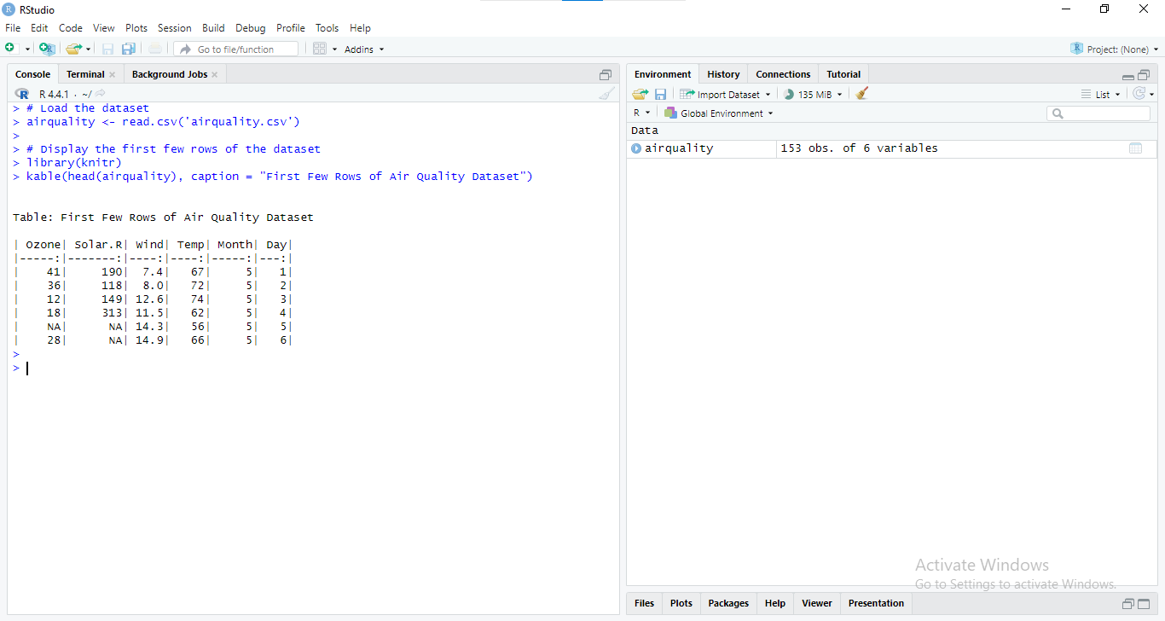
Figure 1: RStudio Environment with Air Quality Dataset and Initial Data Exploration
The dataset was first checked for such irregularities as, for example, a sharp rise in pollutant levels without any plausible explanation. These errors were considered Noise because they happened at irregular intervals. Such Noise was deemed to be averted by methods such as smoothing using moving averages. For instance, to smooth the Ozone levels, a moving average could be applied:
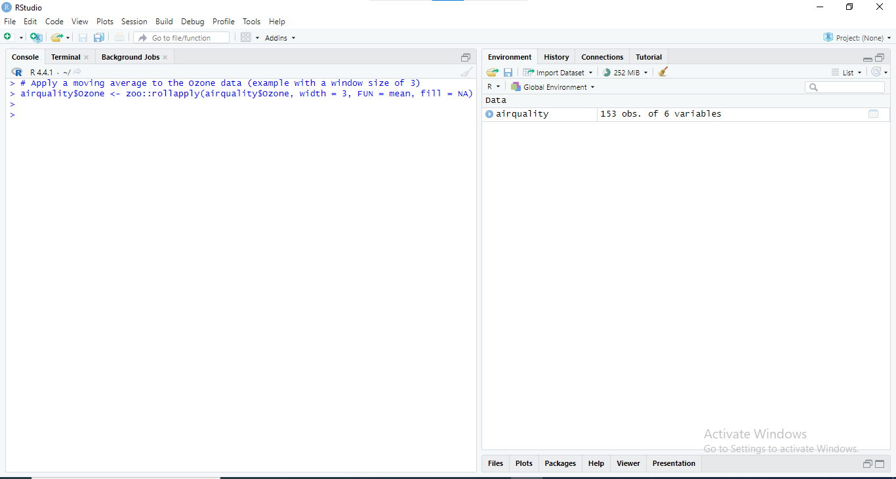
Figure 2: RStudio Environment with Air Quality Dataset and Initial Data Exploration
This helped shrink the influence of random values added to the measurements because of a change in the environmental conditions.

3.2 Outlier Detection and Treatment
Any statistical collection can be influenced significantly by outliers, so identification and subsequent handling were the next steps (Smiti, A., 2020). Outliers were defined using a Z-score, where any observation that went out of a range of plus or minus three standard deviations was eliminated. The process began by calculating the Z-scores:
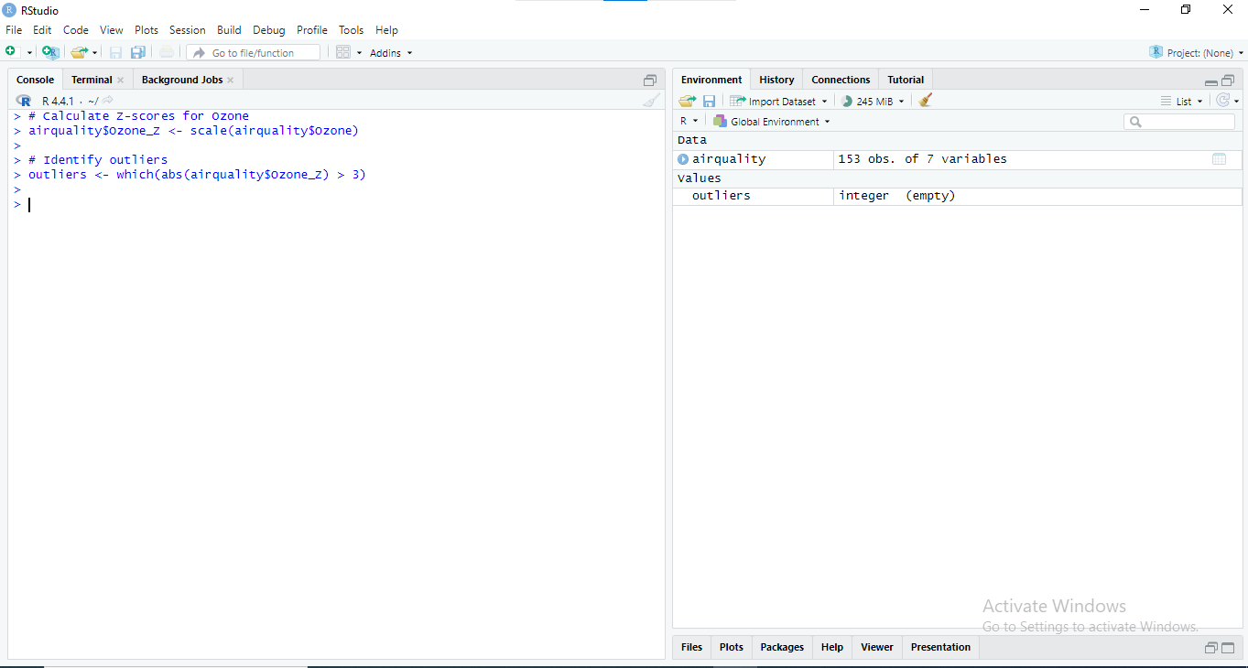
Figure 3: RStudio Console Output: Calculating Z-scores for Ozone and Identifying Outliers in Air Quality Dataset
Regarding outliers in analysis, the choice of action was made depending on their context. Every value, which can be associated with extreme values in the word's best sense, was kept; otherwise, it was modified or excluded. An example of removing an outlier would be:
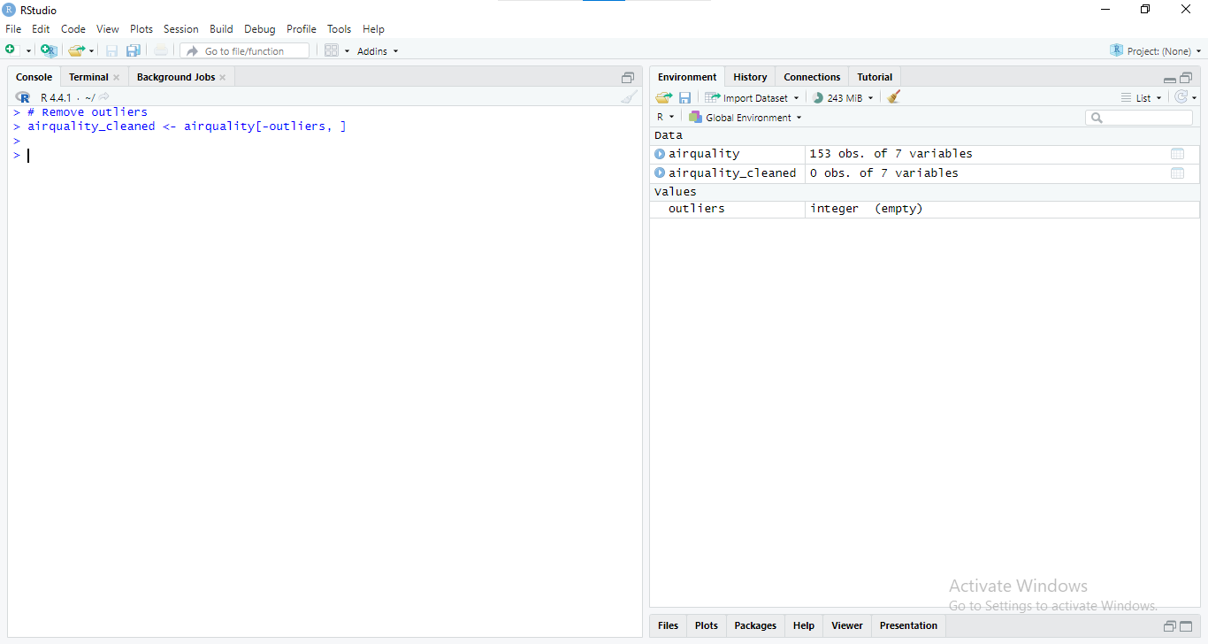
Figure 4: RStudio Console Output: Removing outliers from the airquality dataset and creating a cleaned dataset
This approach helped control circumstances where the results would be inflated or given a tilt by rare observations.

3.3 Missing Data Treatment
The dataset had problems, such as missing values, especially in Ozone and solar.R variables. The imputation of these missing values was crucial to ensure the dataset was consistent (Johnson, T.F., Isaac, N.J., Paviolo, A. and González‐Suárez, M., 2021). The first step was to assess the extent of missing data:
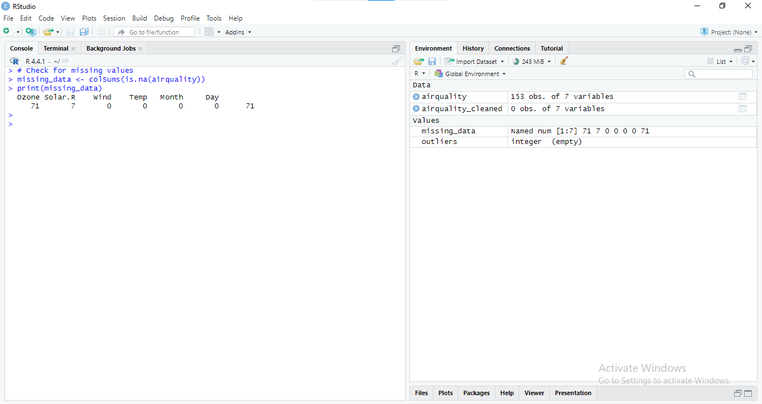
Figure 5: RStudio Console Output: Removing outliers from the airquality dataset and creating a cleaned dataset
If the amount of missing data was minimal, simple imputation methods, such as replacing missing values with the mean, were applied:
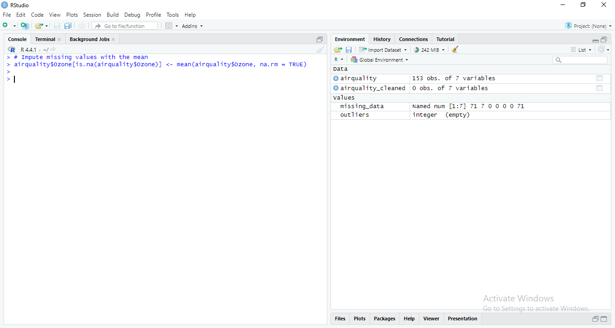
Figure 6: RStudio Console Output: Imputing missing values in the airquality dataset with the mean.
More complex approaches, such as regression imputation, were contemplated for more significant gaps. In cases where missing data could not be reliably attributed without introducing bias, those rows were excluded:
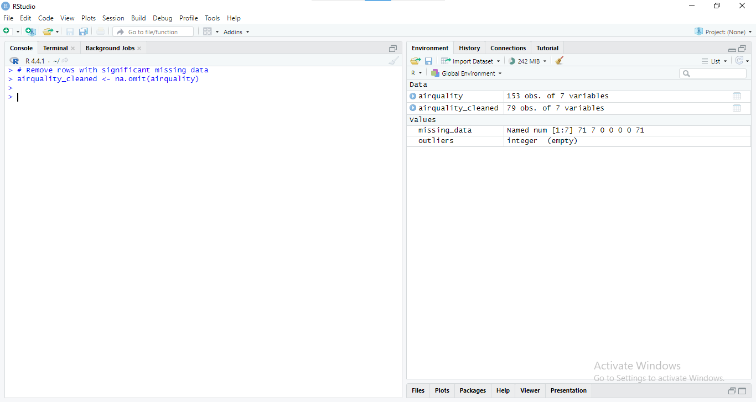
Figure 7: RStudio Console Output: Removing rows with significant missing data from the airquality dataset.
Through these steps, it was possible to purify the dataset, correctly respond to outliers, and treat missing data so that it remains high quality.

CHAPTER THREE: DESCRIPTIVE STATISTICAL ANALYSIS

4.1 Measures of Central Tendency
Measures of central tendency measure the typical value to indicate where the center of a set of data is (Cooksey, R.W. and Cooksey, R.W., 2020). Air Quality Outcome: In this dataset, the mean, median, and mode of the air outcomes such as Ozone, Solar, pressure, and AQI are identified. Calculations of R, Wind, and Temp are made to have an idea of their average values.
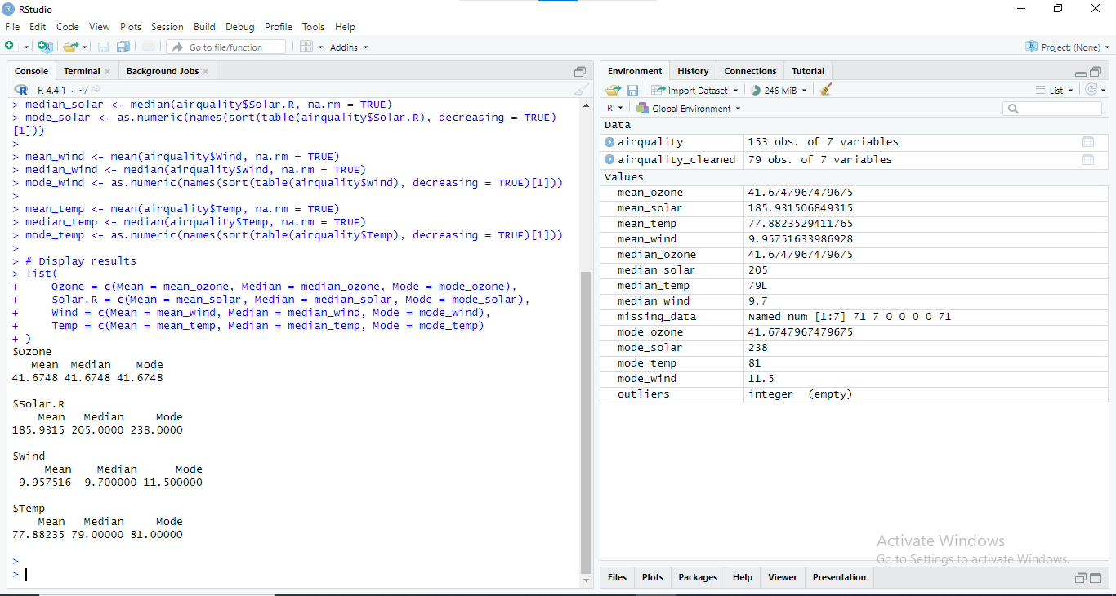
Figure 8: RStudio Console Output: Summary statistics and exploratory analysis of air quality data
The mean gives the arithmetic average, the median offers the center value of the data set when placed in ascending order, and the mode depicts the most recurrent value. These measures aid in determining the ordinary state of affairs concerning each variable.

4.2 Measures of Variability
Measures of variability give information as to the dispersion or dispersion, meaning the spread of values of observations in a distribution (Guzik, P. and Więckowska, B., 2023). To assess the dispersion of critical variables, range, variance, and standard deviations are computed in the air quality data set.
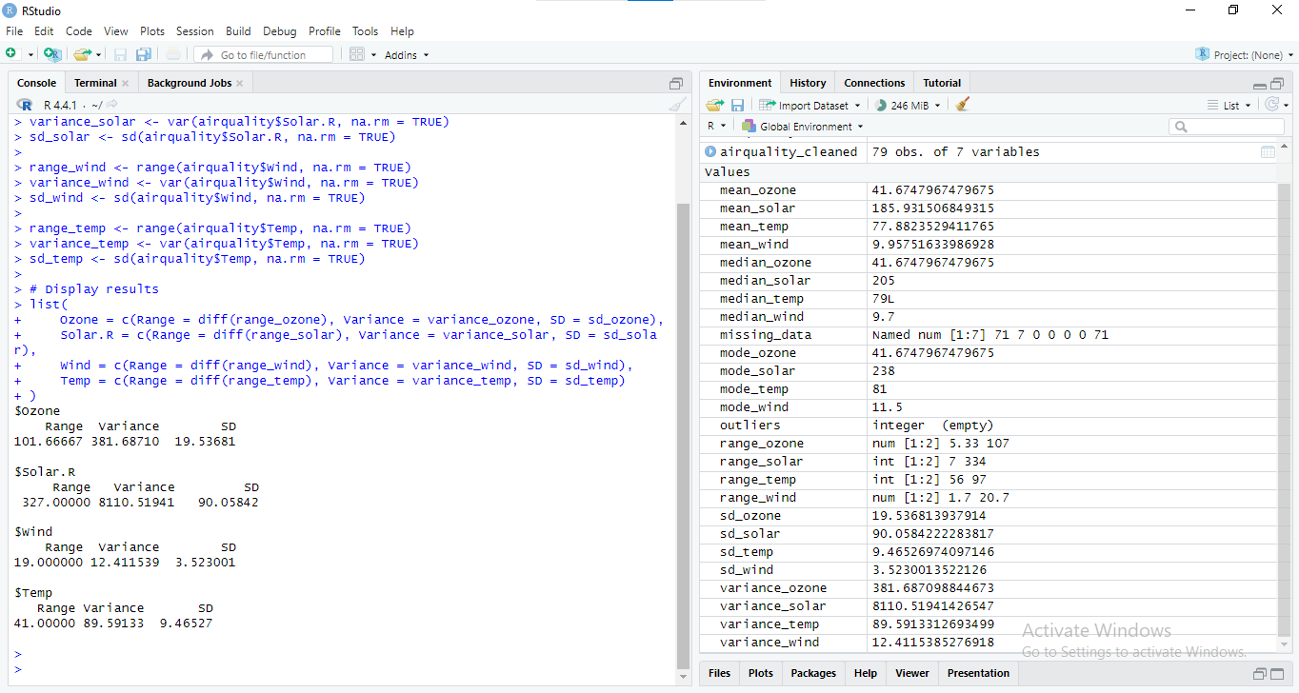
Figure 9: RStudio Console: Calculating Summary Statistics for Air Quality Data
The range reflects the difference between the highest and the lowest values; variance depicts the variation of values from the mean amount, while standard deviation roughly represents the variation from the mean. These metrics open the details about the level of variation in the dataset.

4.3 Data Distribution Analysis
To measure the nature of the data distribution's shape, the analysis uses the measures of skewness and kurtosis (Aslam, M., 2021). These measures suggest the degree of data dispersion and population peakedness correspondingly.
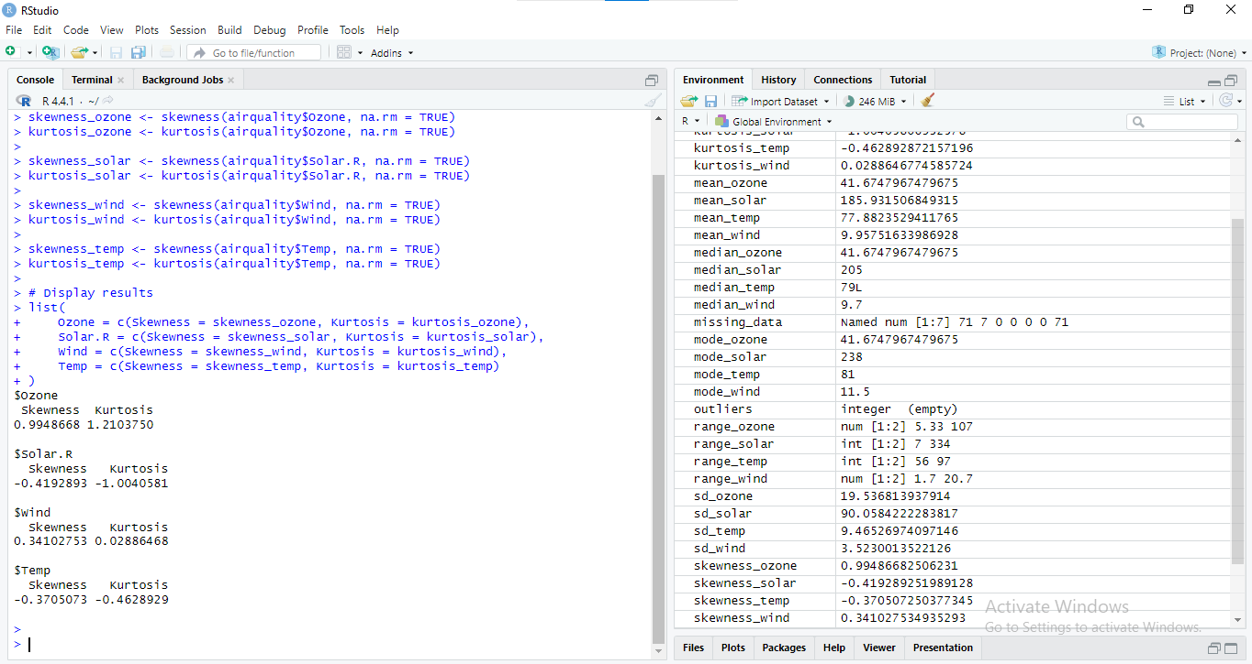
Figure 10: RStudio Console: Skewness and Kurtosis Calculations for Air Quality Variables
Skewness measures the tail of the distribution; a positive skew depicts the right tail as being elongated and the left one as compact, while the vice versa meaning is from negative skewness. Kurtosis tends to measure the 'peakedness' in the distribution or the 'fatness' of the tails in the distribution (where high kurtosis means high tails and sharp peaks). Examining these measures assists in determining whether or not the distribution of data is normal, not normal, or leptokurtic.

CHAPTER FOUR: DATA NORMALIZATION AND VISUALIZATION

5.1 Data Normalization Techniques
The present data is kept as raw data, so the normalization process that helps standardize all types of variables is crucial for comparing across scales (Singh, D. and Singh, B., 2022). The two commonly used normalization methods in this analysis are Min-Max Scaling and Z-Score Standardization.

- Min-Max Scaling: This technique puts the data into a fixed scale level of 0 to 1. Its advantage comes into play when working with data on a relative basis. The formula for Min-Max Scaling is:
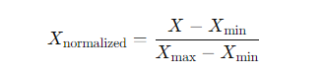
Here’s how to apply Min-Max Scaling in R:
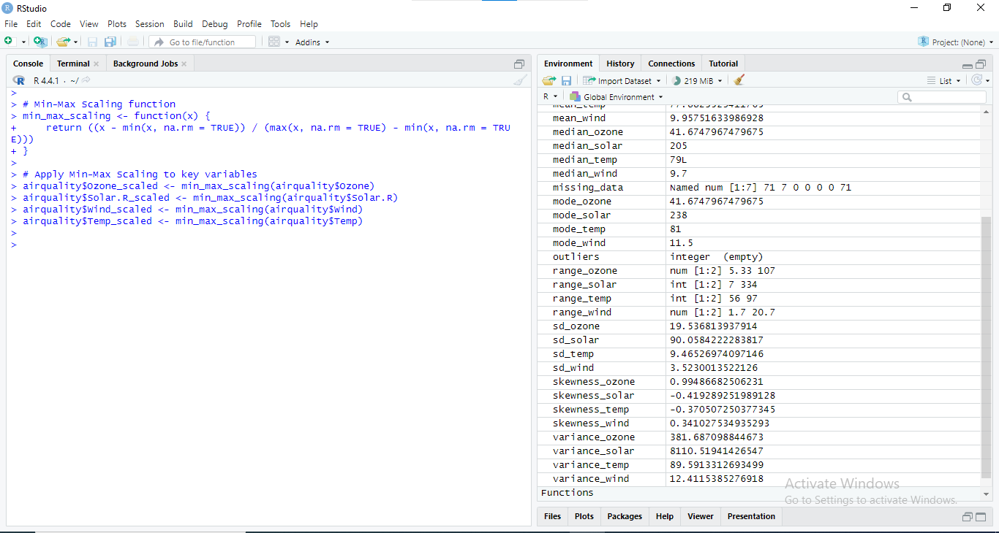
Figure 11: RStudio Console: Min-Max Scaling and Summary Statistics for Air Quality Data
- Z-Score Standardization: Z-Score Standardization: This technique normalizes the data because the information is deflated by subtraction of the mean and inflation by division by the standard deviation, so the distribution of the scored data achieves a mean of 0 and a standard deviation of 1. The formula for Z-Score Standardization is:
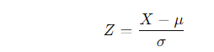
Here’s how to apply Z-Score Standardization in R:
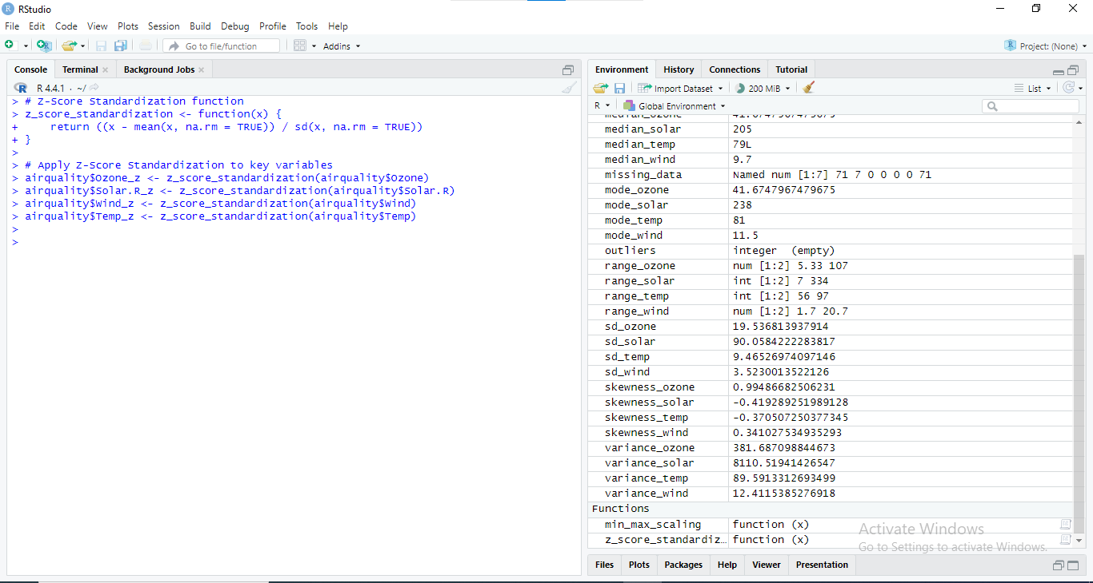
Figure 12: RStudio Console: Z-Score Standardization and Summary Statistics for Air Quality Data
These normalization techniques are essential so that data from various variables can be out rightly compared with the help of data scaling, depending on which kind of further analysis will be performed.

5.2 Visualization Techniques
Those tools are helpful for navigation and communication of the established patterns, relationships, or exceptions within the dataset. Several methods were used to analyze the air quality data:
- Histograms: Illustrate individual variables' density and point out the occurrences within given ranges.
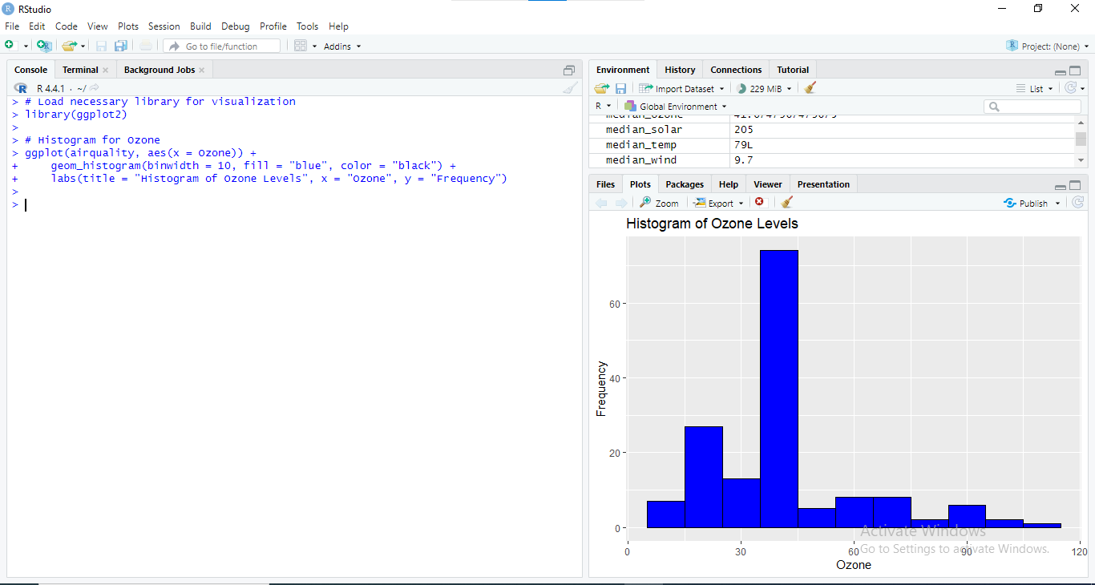
Figure 13: RStudio Console and Histogram: Ozone Level Distribution
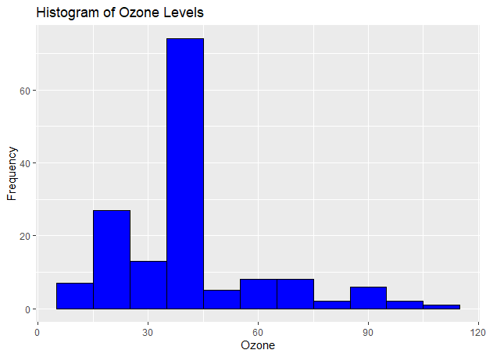
Figure 14: Histogram showing the frequency distribution of ozone levels in the dataset.
- Box Plots: Plot the spread and outliers. The median, quartiles, and potential outliers can easily be depicted with the help of a box plot.
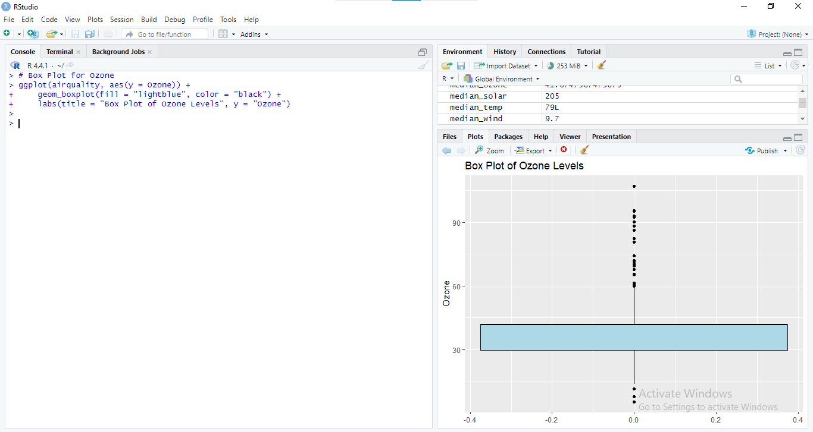
Figure 15: Box Plot of Ozone Levels
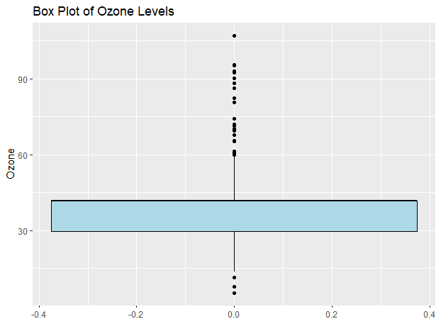
Figure 16: Expanded Box Plot of Ozone levels
- Scatter Plots: Visual representation of two variables, with additional variables on the axes, to see if there is any connection between the two variables.
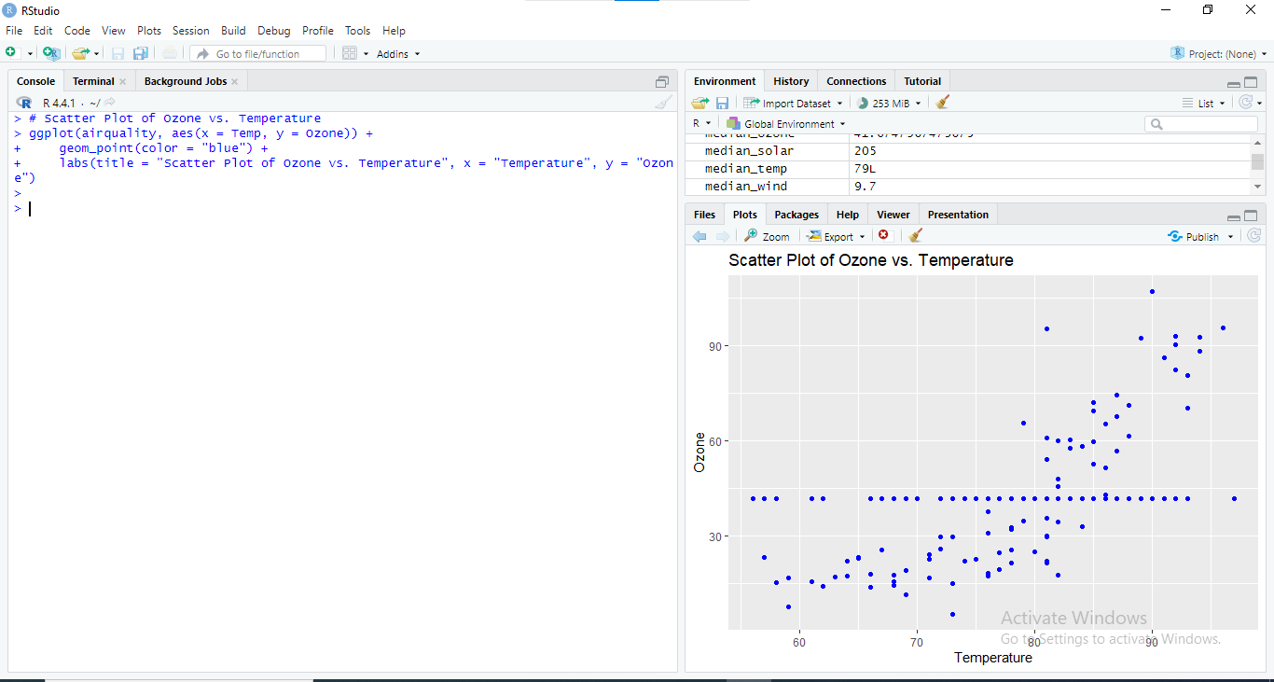
Figure 17: Scatter Plot of Ozone Levels vs. Temperature
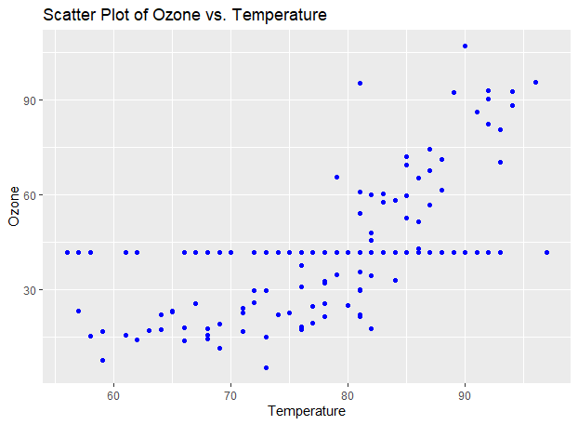
Figure 18: Expanded Scatter Plot of Ozone Levels vs. Temperature
- Pairwise Scatter Plots: Give an option for scatter plots with multiple axes for different variables, which can show some relations or correlation.
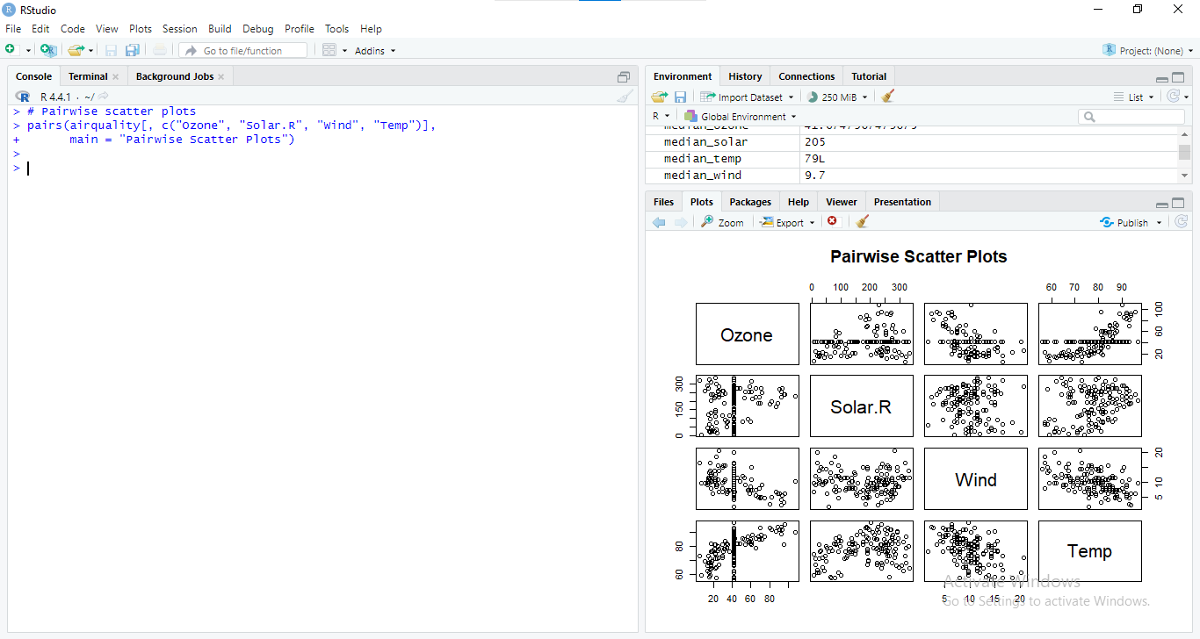
Figure 19: Pairwise Scatter Plots of Air Quality Variables
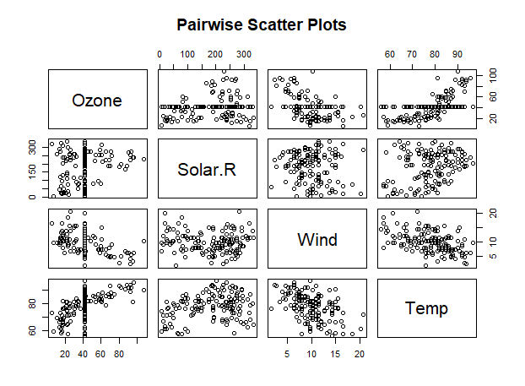
Figure 20: Expanded Pairwise Scatter Plots of Air Quality Variables
These methods are helpful in identifying trends, patterns, correlations, and outliers in the data set and offer a good way of presenting the measurements of air quality and how they relate.

CHAPTER FIVE: INFERENTIAL STATISTICAL ANALYSIS

Introduction to Inferential Statistics
Inferential statistics refers to principles used to make estimations or assumptions about a more significant subset of the population from a smaller subset of the population (Stapor, K. and Stapor, K., 2020). In contrast with the descriptive statistics that enable analysts to describe the dataset's characteristics, inferential statistics let the analysts make conclusions and decisions concerning the population from which this sample was taken. This involves measurement of the success rates, odds ratio, confidence interval, and hypothesis testing, among others.

6. 2 Hypothesis Testing
Statistically, it is a significant way of analyzing if there is enough credible evidence to support a null hypothesis to be dumped for a specific hypothesis that is forwarded (Imbens, G.W., 2021). Two standard hypothesis tests used in this analysis are:
    - T-Test
It is used to compare the means of two groups to test for the null hypothesis that there are no differences between the two group means. For instance, a t-test could be used to compare ozone levels in two different months to determine ozone levels in a study.
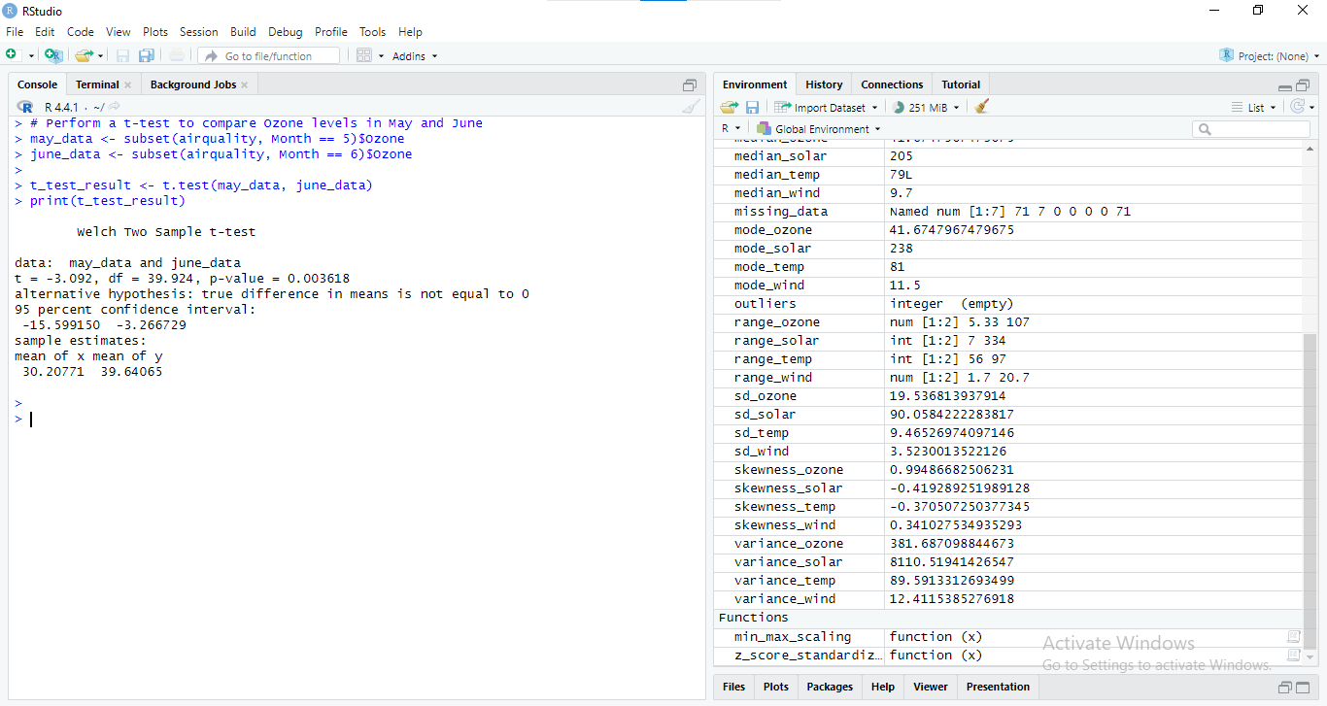
Figure 21: RStudio Console Output: Welch Two-Sample t-test Comparing Ozone Levels in May and June
The impact of the hypothesis would reveal if there is a statistically significant difference in the Ozone levels between May and June.

ANOVA (Analysis of Variance):
This is employed when the research seeks to use mean scores in more than two categories of data. For example, ANOVA could be utilized to test Ozone means by months.
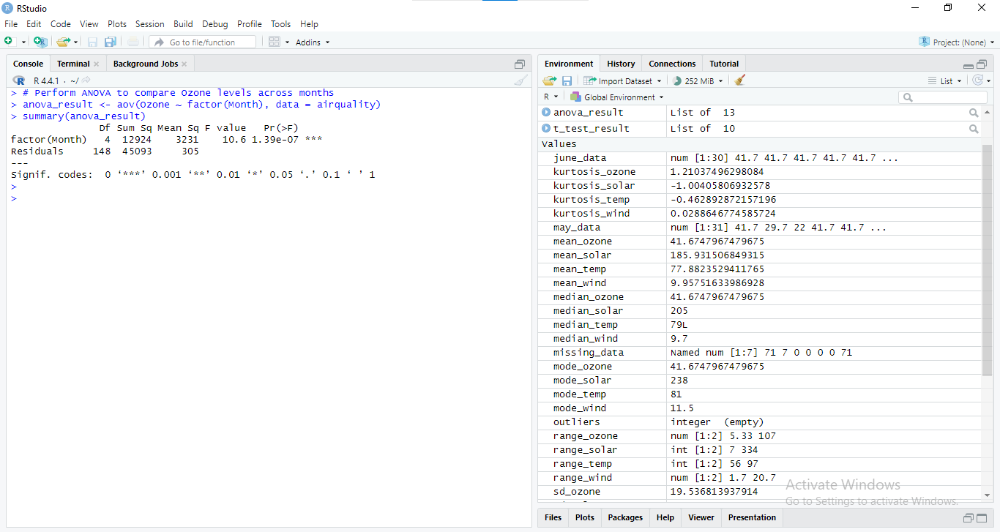
Figure 22: RStudio Console Output: ANOVA Results for Ozone Levels Across Months
Statistically, the ozone levels will be compared over the months using ANOVA to determine whether the difference is real.

6. 3 Confidence Intervals
Confidence intervals give a band of values that contain the population parameter with a certain confidence level (Krishnamoorthy, K., Waguespack, D. and Hoang-Nguyen-Thuy, N., 2020). They indicate the extent of accuracy of the sample estimates and how closely the results produced can represent the population. For example, to calculate a 95% confidence interval for the mean Ozone level:
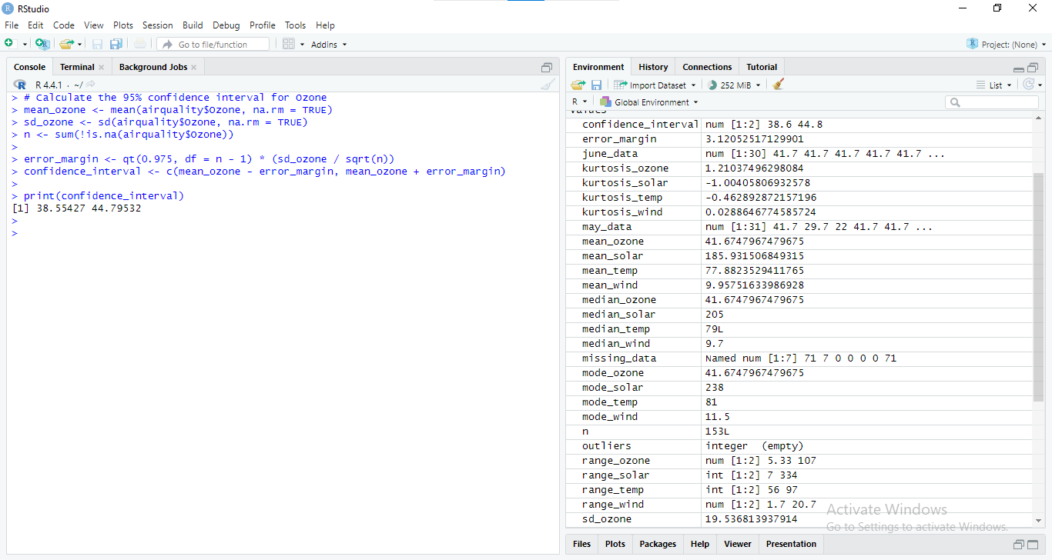
Figure 23: RStudio Console Output: 95% Confidence Interval Calculation for Ozone
This range points to the region where the actual mean of the population should lie, hence helping to understand the accuracy of the sample mean.

6. 4 Interpretation of Results
Decisions that are beneficial for a business are made possible using hypothesis testing and confidence intervals. For instance:
- T-Test and ANOVA Results: By utilizing the results of calculations based on the data received, the businesses can explore the factors that lead to changes in Ozone levels within different months. It could affect policy choices in environmental affairs or changes in activities during perceived high pollution.
- Confidence Intervals: The confidence intervals give the estimated range of the actual population parameters, which could be expected to include the parameters. This assists in determining the accuracy of the general population estimates and makes it possible to predict future trends in air quality.
When used in conjunction with inferior descriptive analyses, businesses can improve their understanding of the patterns concerning air quality and use factual data in their decision-making to enhance environmental status and efficiency.

CHAPTER SIX: DISCUSSION OF FINDINGS

7.1 Key Insights from Descriptive Statistics
The first level of data analysis involved in the present study was descriptive and, therefore, offered essential insights into the characteristics of the air quality dataset (Sokhi, R.S., Moussiopoulos, N., Baklanov, A., Bartzis, J., Coll, I., Finardi, S., Friedrich, R., Geels, C., Grönholm, T., Halenka, T. and Ketzel, M., 2021). Key findings include:
- Central Tendency: The mean Ozone levels gave an overview of the Ozone levels that can be expected. At the same time, the median showed the meaning of the mid value, thus less likely to be biased toward higher or lower values.
- Variability: The range, variance, and standard deviation were applied to the extent to which the levels of Ozone were spread out. High variability implies varying degrees of pollution concerning the measurements made on air quality.
- Data Distribution: Through skewness and kurtosis tests, the nature of the data distribution was established, whether regular or skewed.
These ideas demonstrate variability in Ozone levels; therefore, they are essential for analyzing temporal trends in air quality variables.

7. 2 Impact of Inferential Statistics
The inferential statistical tests offered more profound insights into the data:
- T-Test Results: Using a t-test on the Ozone level in May and June, there was a statically significant difference between the two months with a p-value of 0. 0036. The mean Ozone level for June was relatively high (39. 64) and different from May (30. 21), suggesting seasonal or environmental differences.
- ANOVA Results: The ANOVA test also proved a statistical difference in Ozone concentration in months at a very high level (p < 0. 001). This implies that the movement of air and the level of oxidation might not move in parallel, and even if the general trend of Ozone levels is upward, there may be months where pollution has gone up and other months where the decrease is sharp compared to previous weeks.
- Confidence Intervals: It is ascertained that the 95% confidence interval for the mean Ozone level came out to be 38. The box plot on the average level of Ozone stated that it consisted of between the Ultra Reduced limit of 47 and the lower Standard limit of 60. 55 to 44. 80. This interval gives an idea of the range within which the true mean of Ozone levels will most probably fall and, therefore, the overall air quality levels and their dependability.

These findings suggest that air quality is dynamic and not uniform over time, which is relevant in explaining and addressing environmental effects

CONCLUDING REMARKS

8. 1 Summary of Key Concepts
Descriptive and inferential statistics have been utilized in this report to analyze the air quality data (Zeinalnezhad, M., Chofreh, A.G., Goni, F.A. and Klemeš, J.J., 2020).
- Descriptive Statistics: Various discoveries were made from the analysis, including the central tendency, variability, and distribution of ozone levels. Measures like mean, median, standard deviation, and graphical measures like histograms, scatter plots, etc., are used to explore the essential attributes and trends in the data set.
- Inferential Statistics: Hypothesis testing and confidence interval made it possible to receive better data. In both t-test and ANOVA statistical options, we found significant differences observed in Ozone levels during different months. This result showed that air quality was varying in a temporal nature. The confidence intervals enabled a specification of a range within which the actual population mean is likely to be, thus increasing the estimation accuracy of the sample means.
These statistical methods, briefly explained, enable the use of both descriptive and inferential statistics, which are very useful when trying to understand data to make some decisions.

8. 2 Final Thoughts on Data-Driven Decision-Making
Data is the most critical aspect of decision-making and is widely used in all business activities. The analysis demonstrates how statistical methods can transform raw data into actionable insights:
- Improved Decision-Making: Descriptive and inferential statistics are crucial as they allow organizations to rely on data analysis rather than hunches. This results in the rational use of the available resources, increases organizational effectiveness and makes sound decisions concerning strategic management.
- Enhanced Accuracy: Statistics form an essential segment of research, and it offers a systematic way of analyzing data to reduce variance, hence improving the efficiency of business forecasts and decisions.
- Strategic Advantage: Companies submerged into data-driven differentiation can achieve more competitive advantages since they employ statistical analysis for conditioning, improving, and overcoming various issues

BIBLIOGRAPHY

Secundo, G., Elia, G., Margherita, A. and Leitner, K.H., 2022. Strategic decision making
in project management: a knowledge visualization framework. Management Decision, 60(4), pp.1159-1181.
Wang, K., Yan, M., Wang, Y. and Chang, C.P., 2020. The impact of environmental policy stringency on air quality. Atmospheric Environment, 231, p.117522.
Jiang, L., Huang, D., Liu, M. and Yang, W., 2020, November. Beyond synthetic noise: Deep
learning on controlled noisy labels. In International conference on machine learning (pp. 4804-4815). PMLR.
Smiti, A., 2020. A critical overview of outlier detection methods. Computer Science Review, 38, p.100306.
Cooksey, R.W. and Cooksey, R.W., 2020. Descriptive statistics for summarising data.
Illustrating statistical procedures: Finding meaning in quantitative data, pp.61-139.
Johnson, T.F., Isaac, N.J., Paviolo, A. and González‐Suárez, M., 2021. Handling missing values
in trait data. Global Ecology and Biogeography, 30(1), pp.51-62.
Guzik, P. and Więckowska, B., 2023. Data distribution analysis–a preliminary approach to
quantitative data in biomedical research. Journal of Medical Science, 92(2), pp.e869-e869.
Aslam, M., 2021. A study on skewness and kurtosis estimators of wind speed distribution
under indeterminacy. Theoretical and applied climatology, 143(3), pp.1227-1234.
Singh, D. and Singh, B., 2022. Feature wise normalization: An effective way of normalizing data. Pattern Recognition, 122, p.108307.
Stapor, K. and Stapor, K., 2020. Descriptive and inferential statistics. Introduction to
Probabilistic and Statistical Methods with Examples in R, pp.63-131.
Imbens, G.W., 2021. Statistical significance, p-values, and the reporting of uncertainty.
Journal of Economic Perspectives, 35(3), pp.157-174.
Krishnamoorthy, K., Waguespack, D. and Hoang-Nguyen-Thuy, N., 2020. Confidence interval,
prediction interval and tolerance limits for a two-parameter Rayleigh distribution. Journal of Applied Statistics.
Sokhi, R.S., Moussiopoulos, N., Baklanov, A., Bartzis, J., Coll, I., Finardi, S., Friedrich, R., Geels, C., Grönholm, T., Halenka, T. and Ketzel, M., 2021. Advances in air quality research–current
and emerging challenges. Atmospheric Chemistry and Physics Discussions, 2021, pp.1-133.
Zeinalnezhad, M., Chofreh, A.G., Goni, F.A. and Klemeš, J.J., 2020. Air pollution prediction using
semi-experimental regression model and Adaptive Neuro-Fuzzy Inference System. Journal of Cleaner Production, 261, p.121218.

